Data Visualization & Design

3 different visualizations

1.

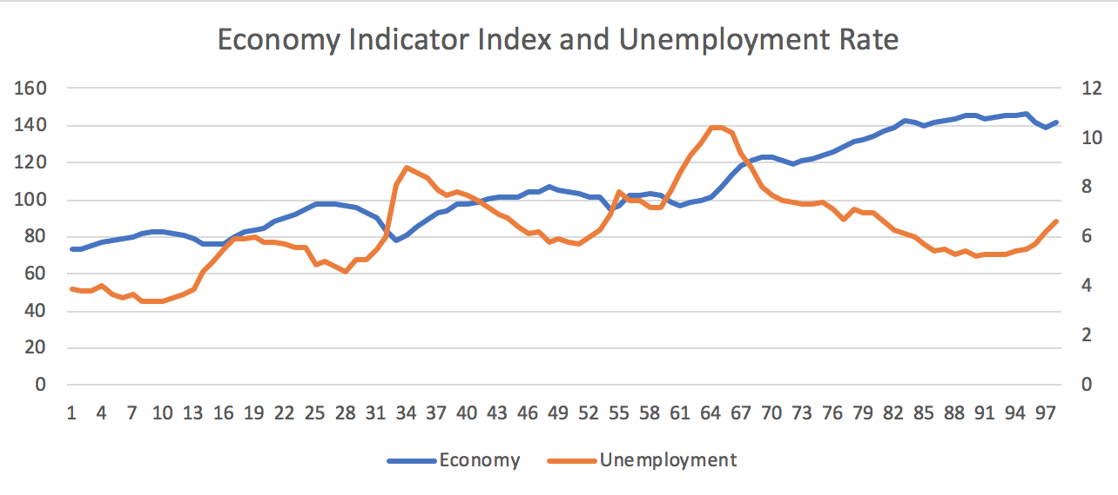

This line chart shows the relationship between economy index and unemployment rate. The left y-axis is the economy indicator index, and the y-axis in the right is the unemployment rate. It is obvious that when economy index number is high, the unemployment rate will be low. Additionally, when time went by, the economy is going better with decreasing unemployment rate.

2. Bond Yield and Prime Bank Rate

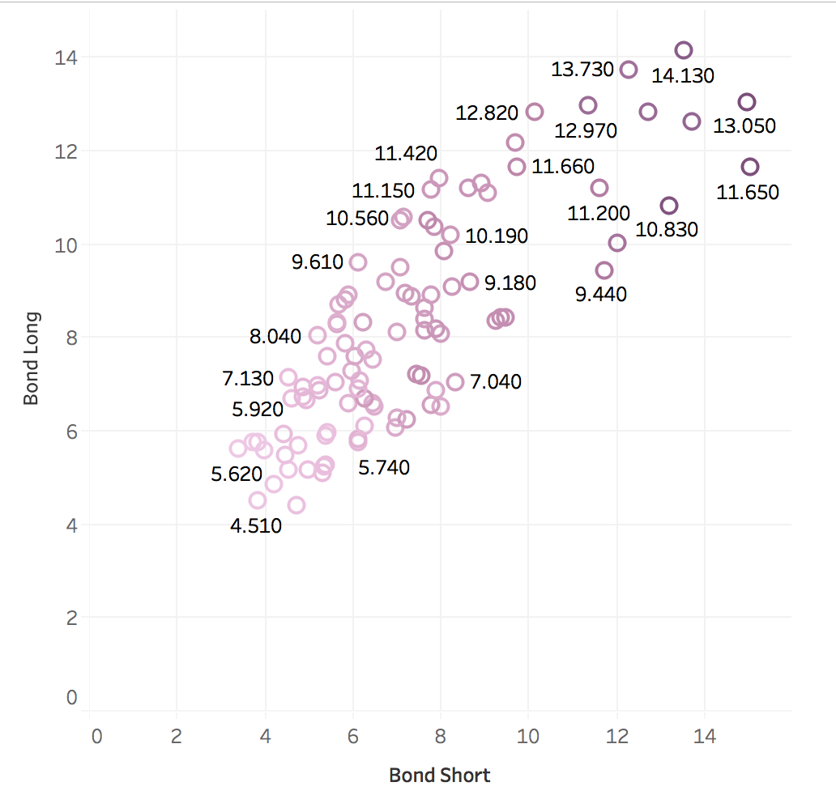

This visualization presents the relationship among Bond Short, Bond Long and Prime Rate from major cities. Purple circle stands for Prime Rate, numerical number stands for the Bond Long (long term treasury bond yield). The deeper the color, the higher prime rate. We can see from the visualization that when prime rate go up, Bond Long and Bond Short are following it to go up.

3. Scatterplot

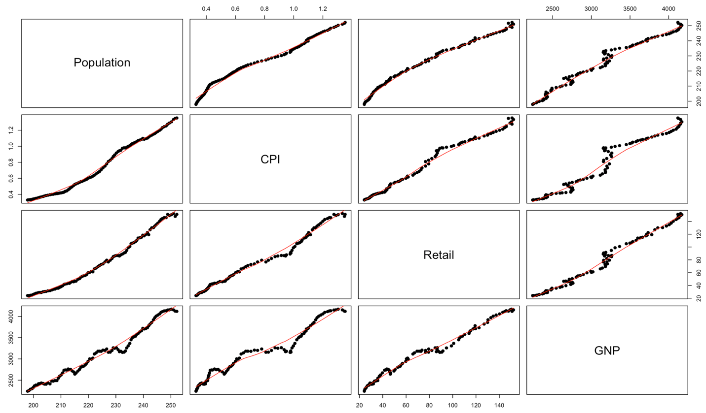

The scatterplot shows the relationship of Population, CPI, Retail and GNP. We can vividly see that they are positive correction for each other (linear regression relationship). The red lines show trend of all points.